Install OpenVPN on Windows 7

- Unzip files from your-name.zip, which has the santanet vpn configuration files and instruction

- Run “openvpn-2.2.2-install.exe”, and install OpenVPN program with default options

- Copy all unzipped files, and paste them into the following folders
c:\program files (x86)\openvpn\config

5. Open All Programs menu, right click on OpenVPN GUI, and select Properties
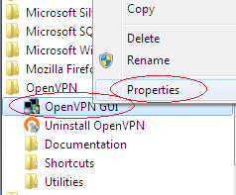

- Click the Compatibility tab, and make sure to check the “Run this program as an administrator”; otherwise, it will be the problem to connect to vpn.
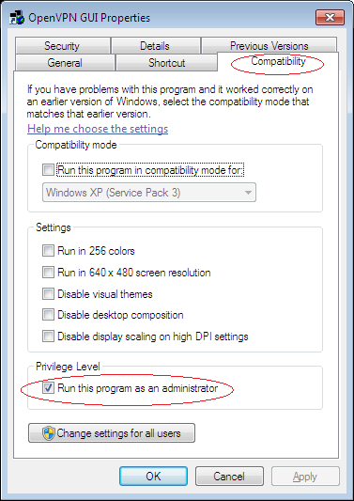

7. Double click the OpenVPN GUI icon to run the Santanet OpenVPN.


8. A red double computers icon will show up on the windows system tray, right click the icons, and select either “SANTANET-UDP1194-Internet” for the vpn connection from your Home Internet (or WAN in general). Select “connect” for starting the vpn connection. Note : “SANTANET-UDP1194-DellBlue-A (or B)” is for connection from Dell Blue corp network only (blue cable or “East” wireless).

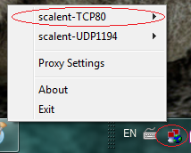

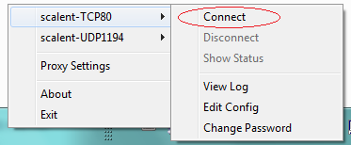

9. After you finish the job with vpn connection, please select “Disconnect” to disconnect the vpn session.

